Terms of Reference

Providing documentation, photography and videography for PACS district conclaves

About PACS:
Poorest Areas Civil Society Programme (PACS) is an initiative of the UK Government’s Department for International Development (DFID) in partnership with civil society. PACS helps socially excluded communities to claim their rights and entitlements more effectively. PACS focuses on socially excluded groups including Scheduled Castes, Scheduled Tribes, Muslims, women and people living with disabilities. This seven-year programme (2009-2016) aims to support civil society organisations (CSOs) in promoting inclusive local, district and state policies, programmes and institutions. It focuses on areas of livelihood, education, health and nutrition in gender and rights perspectives. The PACS programme is being implemented in 90 districts across 7 states of Bihar, Chhattisgarh, Jharkhand, Madhya Pradesh, Odisha, Uttar Pradesh, and West Bengal. The PACS programme is managed by the IFIRST Consortium (Indian Forum for Inclusive Response and Social Transformation), the management consultants for the programme which is a consortium of five organizations led by Christian Aid with Caritas India, Financial Management Service Foundation (FMSF), Indian Institute of Dalit Studies (IIDS) and Access Development Services.

About District level conclaves
One of the key interventions of the PACS programme is focused on empowering CBOs to engage with duty bearers systematically and keep their struggles for increased uptake of rights and entitlements alive. PACS has regularly invested in capacity building and handholding support of CBOs through various means to assist them evolve as empowered and sustainable grassroots institutions of change.

Year 2014-2015 aims to take this energy to the next level through district level CBO conclaves. The district level conclaves will focus on creating conditions for greater alliances for a sustainable impact by catalyzing the process of strengthening civil society (CSOs and CBOs) around issues which, from the standpoint of the socially excluded communities are critical especially at the level of the district. At this stage of the PACS programme, it is crucial that CBOs as well as CSOs initiate the process of coming together as networks/ alliances which will keep issues of the socially excluded communities alive and will play the role of an active advocacy platform. The event will put in place the starting processes of bringing together CSOs, CBOs as well as other civil society actors who can play a critical role in this context. The platform will not be limited to PACS CSO partners, and will bring non PACS partners on board as well.

Objective of Assignment:
We are looking for a consultant proficient in development communication, videography and photography and over time have highlighted initiatives and campaigns through powerful images.

We would want the consultant to report about the conclave, its proceedings, discussions, stories, anecdotes and participants experience from the site of the conclave through images and captions and also provide communication support on the venue as well as online to PACS.

Through this assignment PACS wants to be able to capture and illustrate the proceedings of the event and the impact of the district level event through stories of positive change using a range of mediums – text, photography and videography.

The stories that are gathered will be primarily be used in two mediums
- shared via the website and through PACS social media channels.
- To be turned into a four to six page print ready document for wider circulation.

Scope of Work:
The consultant/agency are expected to present at the district event and develop the following products. One may chose a single or multiple product depending on their capability and interest.
Photography:
- 100 images per event – These should include the various proceedings of the event and would be accompanied by captions. The caption should set the context (two – three lines of what the photograph depicts) and direct quotes. The captions need to be marked and submitted in a separate word document. A note on the type of imagery is mentioned in annex A
- Four photo stories per event – one of the event proceedings and three of key persons from community or group mobilization. The photos in the series should connote a story line and should have a minimum of 50 words of text accompanying each visual
Documentation
- Four to six page document that will narrate the proceedings of the event. It should have a good balance of images, text, change stories and key highlights of the event. The framework of the document needs to be approved before commencing work on the document.
Video
- Five to seven minute video per event on the look and feel of the event. A brief for the pitch and story line will be provided on commencement of the event. A video brief on the tone of the narration and imagery will be provided at the beginning of the assignment.

Processing content – the content should be delivered to PACS in agreed formats. Processing will take a number of forms including editing videos and photos, writing narrative stories and case studies, compiling photo stories and captioning images.

Providing the first draft of products and incorporating suggested revisions and feedback – the consultant will need to provide products to PACS for feedback on narration, photographs and video/audiovisual material and this should be incorporated into the final versions and edited cuts.

A separate briefing meeting, branding guidelines and photography style will be shared with the consultant/agency before the commencement of the assignment

Key deliverables per event – as selected by the consultants
- Edited selection of 100 high quality photographs with captions as mentioned in Annex 1. These photographs should clearly show the case study environment, theme and subjects. They should be delivered as high resolution, digital images. The minimum file size should be 5MB and they should be in JPEG format set at 300 dpi resolution. Captions should be supplied as a separate document with corresponding image numbers. These have to be provided in 2 DVD copies.
- Four photo stories per event – one of the event proceedings and three of key persons from community or group mobilization. The photos in the series should connote a story line and should have a minimum of 50 words of text accompanying each visual. These should be provided in separate folders clearly marked in two DVD copies.
- Four to six page high quality print ready document that will narrate the proceedings of the event. It should have a good balance of images, text, change stories and key highlights of the event. The format for the same should be finalized before the event in consultation with PACS. These have to be provided in 2 DVD copies.
- Professionally edited high quality five to seven minute video on the look and feel of the event. A brief for the pitch and story line will be provided on commencement of the event. The video should clearly and succinctly show the impact and proceedings of the event through a mix of footage, narration, background score and subtitles/text. All interviews should be subtitled. Videos should be delivered in high resolution (for screening) in two DVD copies and low resolution (for website use – MPEG format). The audio should be clean, high quality audio.

Time frame
The time frame of the assignment will be a total of 15 days which will include pre event, event and post production time.

Eligibility criteria
The following eligibility criteria are required to carry out the assignment:
- Experience of doing assignments of a similar nature for the development sector.
- Proven experience in story gathering and interviewing.
- Proven experience in filming, audio recording and photography along with associated editing.
- Experience of working with translators.
- Ability to take up assignments at short notice.

The following criteria is preferred
- Knowledge of community development, especially on community mobilization processes, networking and community context.
- Fluent in English and Hindi/Bengali/Odiya.

Annex A

Photography style:
Photographers should try to capture a mix of:
Portrait shots – photos of key speakers or participants in action | 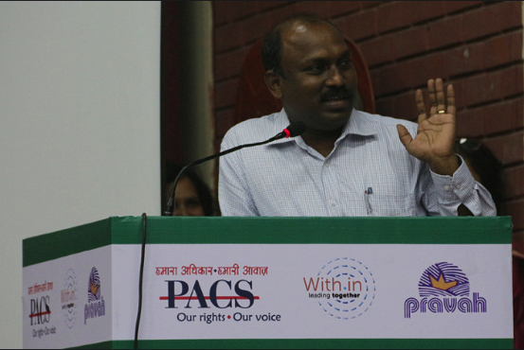
Interactive shots – photos of participants interacting | 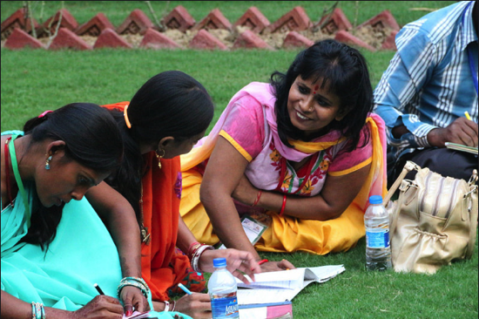
Action shots – photos of dancing/singing or other activities | 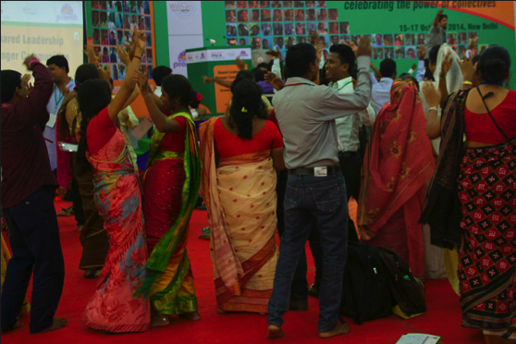
Close-up shots – close-up photos of various objects related to the conclave | 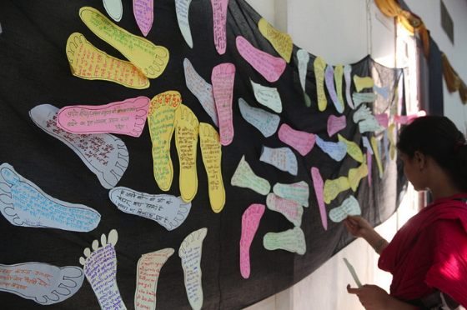

Photos and captions:
An edited selection of high resolution (300dpi minimum) photographs (maximum 100 photos) should be sent to the Communications Team as soon as possible after the end of the event, alongside detailed captions of what each photograph shows. Captions should include:
- Names of key individuals featured in photos, district, village, designation (if available)
- Description of what’s going on in the photo (2 – 3 lines)
- Quotes from individuals featured in photos (where known)

Photo stories:
The photo stories are for the purpose of narrating the stories through effective images and minimum text. Each story should have a minimum of 8 – 10 images. The images of each photo story should be high resolution, digital images. The minimum file size should be 5MB and they should be in JPEG format set at 300 dpi resolution. The text should draw a story and also talk of what the image connotes.

