RESUME
KAMALESH BHAKAT  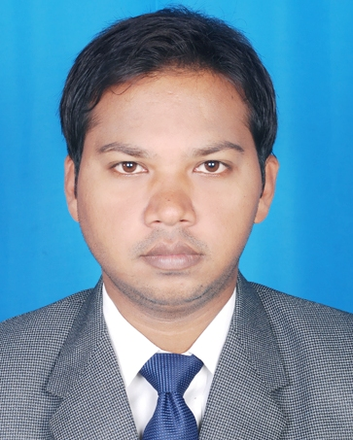  Email ID: kamaleshbhakat21@gmail.com  COMMUNICATION ADDRESS:  TYPE-II/2/13 UCIL COLONY JADUGODA, DIST-EAST SINGHBHUM JHARKHAND 832102  PERMANENT ADDRESS:  TYPE-II/2/13 UCIL COLONY JADUGODA, DIST-EAST SINGHBHUM JHARKHAND 832102  CONTACT NUMBERS:  Mobile: 9204938456  PERSONAL PROFILE  Date of Birth : 21/08/1987  Gender : Male  Marital Status : Unmarried  Nationality : Indian  LANGUAGES KNOWN  English  Hindi  HOBBIES  Photography  Cooking | CAREER OBJECTIVE  To give the best performance and achieve the goals of an organization.  CURRENT STATUS  PGDM (FINANCE & BANKING) batch 2012-2014 from Regional College Of Management Autonomous, which is affiliated to AICTE with 7.20 CGPA.  SUMMER TRAINING & PROJECT DETAILS  1) Company: State Bank of India , Bhubaneswar  2) Title: Study on “Effectiveness of in branch advertisement and  Marketing techniques”.  Duration: 60 Days  Responsibilities:  - To know about the effectiveness of advertisement of state bank of India.  - To maintain good relationship with the corporate employees.  - To find out the services that other bank given to their customer.  - To make aware to the customer about latest products and services of state bank of India.  - To make the customer to aware of the benefits of the product and convince him to go for SBI Products.  - To determine how interested customers for SBI products and services.  - To find out the various complains of customers.  WORK EXPERIENCE  Worked as Accounts Executive in Globlink Hotels for the period of 1 year.

EDUCATIONAL QUALIFICATION
Degree | Month & Year of  Passing | Percentage/ Grade Points | Name of University
PGDM | 2014 | 7.2 | AICTE
M.com | 2013 | 60% | KOLHAN UNIVERSITY
Graduation | 2011 | 70% | RANCHI UNIVERSITY
Intermediate | 2008 | 61.40% | CBSE
10th | 2006 | 62% | CBSE

MY STRENGTH
- Self-confidence.
- Positive attitude & Team Work.
COMPUTER PROFICIENCY___________________________________
- Basic knowledge in MS Office, Excel, PowerPoint.

DECLARATION
I am also confident of my ability to work in a team. I hereby declare that the information furnished above is true to the best of my knowledge.

(kamalesh bhakat)
Place: Jadugoda
Signature
Date: 05-04-2014

